After visualizing dataset, I come up with answer of the question asked from your end related to dataset…Visualization is best to understand the data (also for non tech guys) and in this document I am not considering any code (I push code in my GitHub) because the all below report is generated using BI tool.

**Question 1:** If the market has only two media players i.e., PLAYER 1 & PLAYER 2 - do you observe any uptrend/ downtrend in the overall Advt. flow year-on year? Support your observations with data points.

**My Observation:** After visualizing the up and down trend of each publicationusing **POWER BI** (Screen short of report is attached below) I found:

**Upward Trend** in FY 2018-2019 for both Publication and **Downward Trend** in FY 2019-2020 for both Publication.In 2018 Player 1 had 9.1k advertiser count, in 2019 it goes little high with 10.4k advertiser count but in 2020 again it falls down with 6.6k advertiser count. We clearly understand by look over the report below that Player 2 had 16.1k advertiser count in 2018 and it goes up with 19.0k advertiser count in 2019 and falls heavily down with 9.6k advertiser count in 2020.

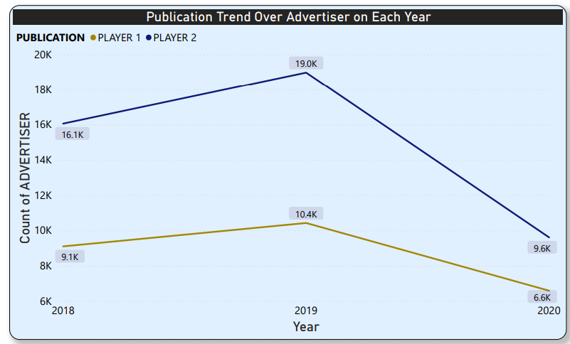

**Question 2:** What are the highlights in the performance of Each Player? Identify 5 Super Categories & Advertisers where Each Player is strong. Support your answers with data findings.

**Answer:** After Seeing the above report (report attached in solution of question no 1) we found that Player 2 is strong relation in market compared to player 1, by seeing the count of advertiser.

Here in this task 2, we found what are the top most (in our case top 5) SUPER CATEGORY of both the publication i.e., PLAYER 1 and PLAYER 2 where they are strong in count of advertiser.

The below report shows that EDUCATION, SERVICES, AUTO, MISCELLANEOUS, RETAIL are the sector where each publication is in huge (you asked for top 5, so in power bi there is filter option available to select top 5, I am do this for sub category)

.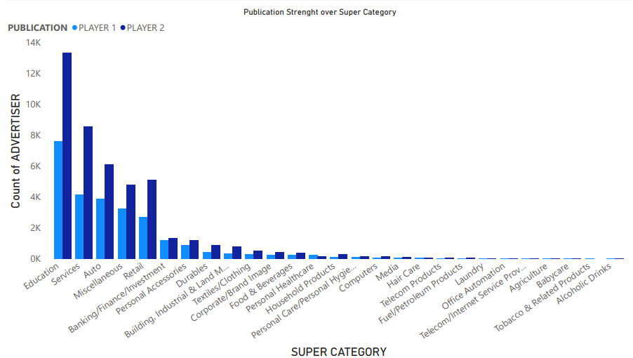

Now we done with top 5 SUPER CATEGORY, what about advertiser? Let’s see the below report for better understanding of top 5 Advertiser where both publications are strong.

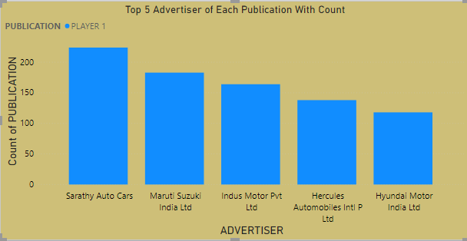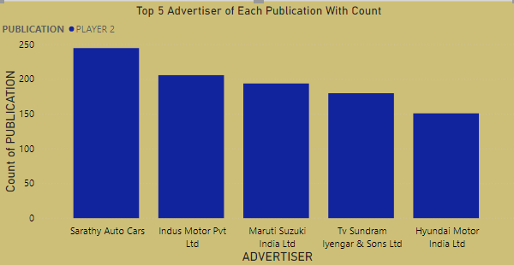

So, these are the top five advertiser or company for whom each publication does most count of advertisement (left plot for player1 and right plot for player 2).

**Question 3:** After examining the performance of both Players in FY 2020-21, what would be your recommendations to Each Player to achieve growth going forward? Establish your arguments with data points.

**Answer: (I am talking about Year Trend not about the growth growing forward)** After analysing the data for FY 2020 – 2021, I found that each Players 1 and Player 2 are not having constant upward trend, their business falls down in first quarter i.e., from JAN to MAR and after that they start picking the market.

The below graph is for demonstration.

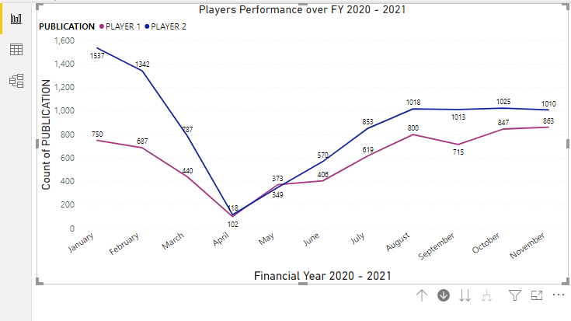

So what is the recommondation to achieve growth going forward?

**My Point:** Growth and trends are different, if you asked me about the growth then I found that making clients in automobile is best becase according to dataset, automobile invest huge on advertisement.

If we talk about the trend then we have to go through each domain and to understand why they don’t put money on advertisement specially during first quarter of year. We have to corelate the industry vs their customer.

**Question 4:** If Player 1 has to select 10 Advertisers for having extended great support to its Publication - which 10 Advertisers would you identify for the same? Give reasons for your selection.

Answer: After analysizing the dataset,considering the Advertiser column and the number of count of each advertiser by Player 1, we come with the beautiful plot, below plot represent the top 10 advertiser by Player 1.

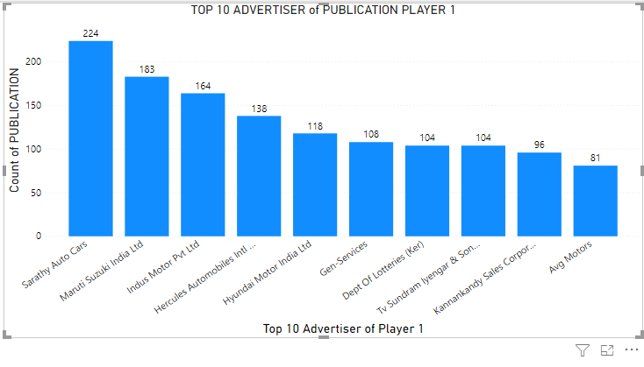

END OF FILE